**Brain Controlled Interface for Controlling Robotic Arm**

**ABSTRACT:**Brain Computer Interface (BCI) refers to the interaction of the central nervous system or the brain with a computer where the signals generated by the brain due to external stimulus are used to control an external device. The electroencephalographic (EEG) signal obtained by the imagination of movements of hands and legs is being used in our project. The EEG signal is susceptible to external noise and hence filtering out the perturbations and from the actual EEG data classifying it and building a system is the challenge.

In this project we have preprocessed the signal to get noise-free EEG signal and extracted features from the EEG signal using time-frequency analysis. ANN model is used for the classification of Motor Imagery electroencephalography (MI-EEG) signals; to avoid overfitting of the data, we have used an early stopping method. Comparison of accuracies is done for different variations of the ANN model.

The output from the model is given to the Robotic arm. Arm can pick lightweight objects from one place and drop it to a predefined place. Robotic Arm is built using raspberry pi, DC motors, H-bridge, pi camera. Object detection is used for object identification, picking and dropping. We achieved an average accuracy of about 71.03 percent.

**1. INTRODUCTION**

The growing number of patients suffering from paralysis is increasing throughout the globe and a lot of people must be dependent on others as they lack mobility. Any disease or injury which results in the lack of voluntary muscle movement can result in the inability of movement of the whole body. The injury of voluntary movement is the main actuator enabling people to move their body. Most patients suffer permanent paralysis while in other cases it can be temporary. BCI technology has the potential to help seriously disabled people with daily activities and human-machine interface applications. The EEG signals obtained from the brain of the user is the main attribute in a BCI system that defines how well a BCI system performs or how well a user can control a system. Robots are increasingly being used in human machine interface systems to help physically challenged people, in addition to robotics and industrial applications. Assistive robots can help disabled people perform everyday tasks in both their personal and professional lives, resulting in increased demand for them. A safe consumer can monitor robots given a variety of traditional input devices such as a mouse, a keyboard, a motion sensor or a teacher pendant in general Human Machine Interface. These machines, on the other hand, are very difficult for physically challenged or older people to use.

One of the most common neurological disorders is paralysis, which results in the loss of motion in one or more muscles of the body. Robots will help injured people who have suffered from neuromuscular injuries. Researchers designed the voice-controlled robots to assist the disabled. There are also a variety of ways to use robots that concentrate on the contact between the person and the robot without the use of a human's hand. By having the requisite facilities and preparation, certain patients' Brain Signals may be used to assist them in communicating with others as well as performing different tasks. The BCI device interprets the brain's electrical activity and produces instructions. As a result, these commands can be used to monitor external machines.

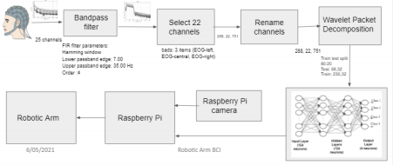

**Figure 1: Brain Robot Interface Schematic**

**2. LITERATURE REVIEW**

2.1. Brain Controlled Interface

Brain Computer Interfaces (BCIs) track brain activity by using electrodes to sense electric signals in the brain that are then transmitted to a computer. After that, the computer extracts features from the task and converts them into outputs that substitute, restore, enhance, complement, or boost human functions.

2.2. Motor Imagery

One of the standard concepts of BCI is brain computer interface based on motor imagery (MI).

In MI, the user can produce induced activity from the motor cortex of the brain by imagining motor movements

without any hand movement or external stimulus. The most convenient basis for designing brain-computer

interfaces is motor imagery signals recorded through electroencephalography. Since MI-based BCI allows for a

high degree of independence, it enables motor-disabled people to communicate with the system by performing

MI tasks in sequence.

2.3. Wavelet Packet Decomposition

The Discrete Wavelet Transform (DWT) is a multi-resolution time-frequency study of signals. DWT is preferred

over Fourier Transform because it has frequency resolution as well as temporal resolution information, which is

why it is called a time-frequency analysis.Typically, the decomposition level chosen is based on the length of the

sequence. The maximum decomposition level (M) can theoretically be determined as M = log2 (N), where N is

the length of the sequence. The wavelet becomes smoother as the quantity of vanishing moments increases.

2.5. Related Work Reference paper[2] was the main reference paper used to introduce ‘Robotic Arm BCI.' We learned how to build a hybrid deep learning model using the CNN and the BiLSTM by using a bandpass filter with Hamming-windowed zero step finite impulse response (FIR). Twenty EEG channels near the primary/supplementary motor cortices were chosen after spatial filtering. The MDCBN-based multidirectional CNN-BiLSTM network (MDCBN) deep learning system was used to consider 3D multi-direction.

Reference [5] was used to investigate various classification techniques. They used three separate classification algorithms in this paper: SVM, KNN, and LDA. When all classifiers were compared, LDA had a higher accuracy of about 87.5 percent. Matlab and an Arduino board were used to interface with the robotic arm. The robotic arm is controlled wirelessly by the Bluetooth module.

The paper[3] introduced the idea of spatial filtering using typical spatial patterns. This paper also provided a brief overview of the Mutual knowledge (MI) algorithm for feature selection and the naive bayesian classifier for classification.

To focus on the interfacing and the usage of Raspberry Pi reference paper [4] was referred. ANN with 1 input layer, 1 hidden layer and 1 output layer. The object's location is fed as an input to the neural network. The neural network will process this data such that it will output a set of three angles at each joint angle of the robotic arm.The performance is measured in

terms of the mean squared error (MSE) for each epoch. MSE decreased as the number of epochs increased.

**3. METHODOLOGY**

3.1 The Dataset Graz University provided Dataset BCI Competition IV 2a, which we used. This dataset contains EEG data of nine healthy subjects who have performed four types of motor imagery: feet, right hand, left hand and tongue movement. For every subject, the dataset is recorded in two sessions on separate days. Each trial consisted of instructing the participant to visualise one of four motor imagery tasks (Feet, Left hand, Right hand and Tongue) in response to a cue. The signals were captured from 22 EEG channels and three monopolar EOG channels in accordance with the international 10-20 framework. They were sampled at a rate of 250 Hz and band-pass filtered in the 0.5-100 Hz frequency range. To reduce power line noise, an additional 50 Hz notch filter was used. The files are saved in.gdf format.

3.2. Methodology of work

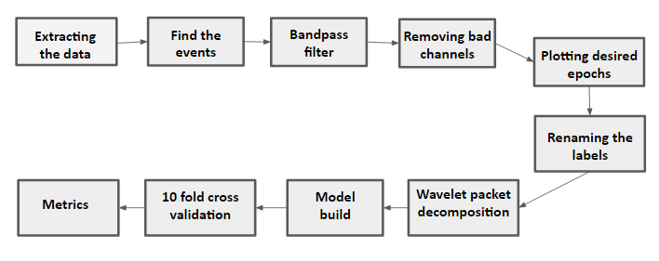**Figure 2: Process step flow diagram**

3.3. Pre-processing

3.3.1. Event Extraction

On the basis of the events, voluntary and fictional movements were gathered, and these events were extracted and divided into 11 forms. Only four events out of eleven were needed, and they are as follows: Cue onset left (Class 1) ,Cue onset right (Class 2) ,Cue onset foot (Class 3) ,Cue onset tongue (Class 4)

3.3.2. Bandpass Filter EEG signals are non-stationary and include alot of noisy signals caused due to objects like eye movement, eye blinks, muscle movement and heart signals that are filtered out of the EEG signal in order to maximise the signal-to-noise ratio. After extracting the necessary events, we pass frequencies in a frequency band via a one-pass, zero-phase, non-causal bandpass filter with a hamming window. The frequency range of 7Hz to 35Hz has been chosen.

3.3.3. Channel Selection

According to the literature review, the majority of EOG channel signals represent redundant information about

brain function. The EEG signals are extracted using 25 electrodes, 22 of which are EEG channels and 3 of which

are EOG channels. EOG channels are regarded as undesirable. The existence of EOG channels in the

classification process will have an impact on the classification rate. As a result, these poor channels are omitted

for improved accuracy, leaving 22 channels for classification.

3.4. Wavelet packet decomposition

We split the EEG signal into sub-bands such as Delta (0.5 to 4 Hz), Theta (4 to 8 Hz), Alpha (8 to 16 Hz), Beta (16 to 32 Hz), and Gamma ( >32 Hz) to analyse it.

On the filtered EEG signals, a two-level Discrete Wavelet Transform with ‘db4’ as mother wavelet was applied, yielding three groups of comprehensive coefficients d3, d4 and d5 from the signal.

| Decomposition Level | Frequency  Bandwidth(Hz) | Frequency Bands |
| --- | --- | --- |
| D1 | 64-128 | Noise |
| D2 | 32-64 | Noise(Gamma) |
| D3 | 16-32 | Beta |
| D4 | 8-16 | Alpha |
| D5 | 4-8 | Theta |
| A5 | 0.5-4 | Delta |

**Table 1: Decomposition level for frequency bands**

A signal's single level DWT is determined by passing it through highpass and lowpass filters, which generate informative and approximated coefficients, respectively. Using Nyquist law, by subsampling the signals with 2, half of the samples can be discarded. The estimated coefficients from every level are decomposed further for N multi-level DWT by continuously passing them through highpass and lowpass filters until the Nth level informative.

3.5. Building the model Artificial neural networks architecture is used to classify the extracted features from the EEG signals into four groups. The model is made up of four layers. The neural network's performance matrix is 4x288, with four motor imagery tasks per 288 data samples. There are 124 neurons in the input layer. A 0.5 dropout is used. Relu is the activation feature used in this layer. The model has two hidden layers, each with 124 neurons, a Relu activation feature, and a dropout of 0.5. The L2 regularisation method was used, and it worked well. Since there are four groups to classify, the output layer has four neurons. Softmax is the activation function used in the output layer. Since this is a multiclass problem, the optimizer chosen for this model is Rmsprop, and the loss is categorical cross entropy.

*Early stopping* The most common issue with neural network training is deciding how many training epochs to use. Overfitting the training dataset can result in a decrease in model accuracy, whereas selecting a small number of epochs can lead to an underfit model. The Early stopping technique allows us to set out a large count of training epochs and then end training when the model's output on a hold out validation dataset stops improving.

3.6. Training

Training was handled with the aid of the proposed model(algorithm). 80% of the total dataset is used for

training the model. From 288 data samples, 230 data samples were used as training set and the remaining 58

data samples were used for testing. The model was initially trained with 300 epochs, after which the early

stopping was implemented such that training loss never goes below validation loss.

3.7. 10-fold cross-validation The initial sample is randomly partitioned into 10 equal-sized subsamples in 10-fold cross validation. A single subsample from the ten is held as validation data for testing the model, while the remaining nine are used as training data. The cross-validation process is then replicated ten times (the folds), with each of the ten subsamples serving as validation data exactly once. The ten folds results can then be summed to create a single estimate.

3.8. Robotic ARM Design

3.8.1. Components to Take into Account

The following considerations were considered when selecting the robotic arm’s shape and material: Price ,The robot's weight ,The ease with which the pieces can be manufactured, Assembly is easy,Parts sturdiness and longevity.

The following are the basic specifications for effective power transmission by the robotic arm: Size is small,Low weight and inertia moment,Effective stiffness is high, Transmission ratio that is accurate and consistent,Low energy losses and friction for improved control system responsiveness and Backlash will be eliminated.

Both of these considerations had a major impact on the robotic arm's design decisions.

3.8.2. Hardware Components

● 4 DC motors - Two motors for controlling wheels and the other two to control robotic arm

● 2 H-bridge - To control DC motors

● Pi Camera - For object colour detection

● Raspberry Pi 3 Model A+ processor 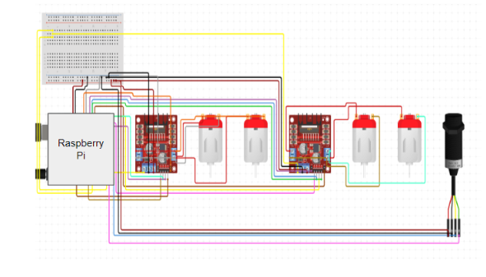 **Figure 15: Circuit Diagram**

3.8.3. Constraints

The constraints which are used in our project are as follows :

● Colored objects are considered to be Lightweight objects

● Input given to robotic arm and object color that has to be picked

○ Class 1 - Left - Orange

○ Class 2 - Right - Red

○ Class 3 - Front - Blue

○ Class 4 - Back - Green

● Based on the input Robotic arm rotates and moves in that direction, detecting the colored object and avoiding the obstacles encountered in the path

3.8.4. Computer Vision

3.8.4.1 RASPBERRY PI SETUP AND CONFIGURATION

● Download the raspberianos and copy the image file onto the SD card using a raspberry imager.

● Run it as CPU connecting it to a monitor keyboard and mouse and complete setup

● Enable VNC and SSH in the pi.

● Download VNC and PuTTY on the laptop to start coding.

3.8.4.2 TENSORFLOW SETUP AND LOADING THE SAVED MODEL

The model weights were saved and sent to the raspbian OS using SCP(Secure copy).In order to send command files over SSH we used secure copy. This is used to copy files between computers, say from your Raspberry Pi to your desktop or laptop, or vice-versa.

Command to transfer files :

scp saved_model pi@172.168.1.3:

Then using the Tensorflow load module(load_model) we loaded the model on Raspberry Pi and provided the input to the model. The model accordingly classifies the input and provides us the class number.

3.8.4.3 Object Colour detection First we captured the video with the help of a raspberry pi camera and read video streams in image frames. Then we converted the RGB colour space to HSV colour space.We defined the range for each colour and created a corresponding mask. Dilation followed by bitwise AND between mask and image frame is implemented to detect a specific colour. Then we created a contour for each of the four colors to view the detected colored area.

According to the output received by the classified result the bot moves in a particular direction. If the classified class is

● Class 1 : turns towards left direction

● Class 2 : turns towards right direction

● Class 3 : moves forward

● Class 4 : moves backward

Figure 21 displays the robotic arm which is used in our project. It contains four DC motors, two motors to control forward, backward, right, left movements and the other two are to control the arm in order to facilitate the pick and drop actions. H-bridge is used to control the speed of the motors.

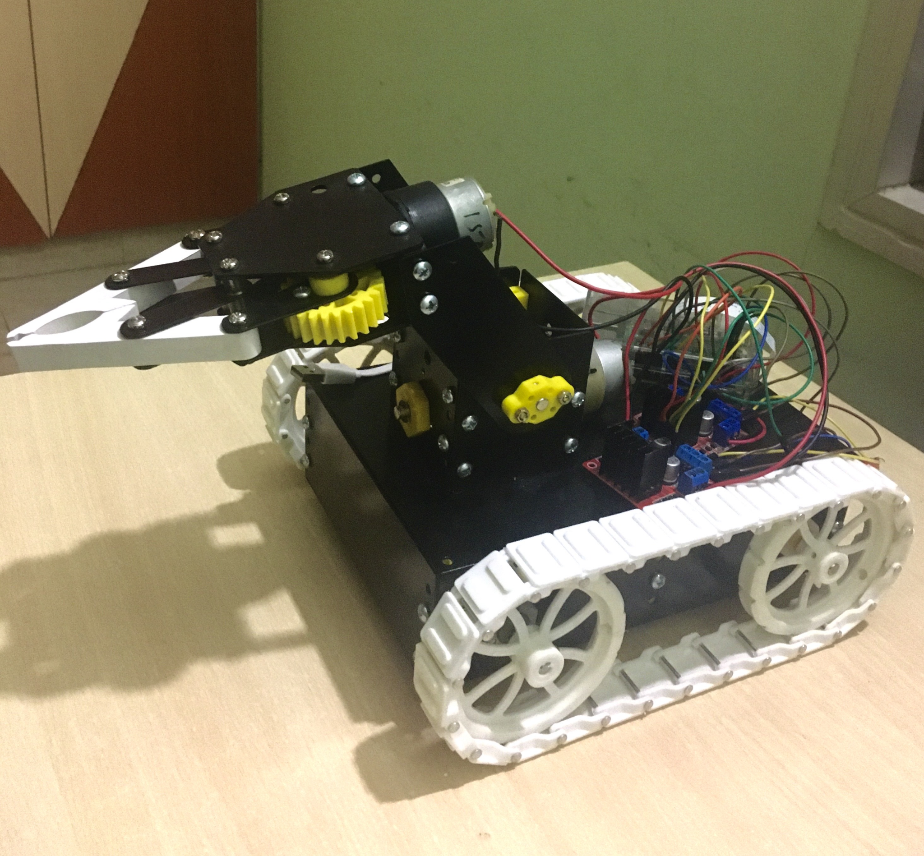

**Figure 21: The Robotic Arm used in the project**

**4. RESULTS AND DISCUSSION**

The total accuracy of all four classes (Class 1- Left, Class 2- Right, Class 3- Forward, and Class 4- Backward)

is obtained. The 10 Fold Cross Validation approach is used to measure the overall average accuracy of the

neural network for the subjects across various features.

Table 2 shows the average classification accuracy, fold accuracy, kappa, precision, recall, and fold

accuracy for different statistical features derived from 22 channels.

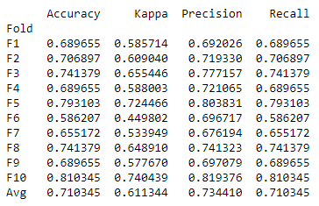

Table 2: Accuracy of Classification

**5. Conclusion**

The arm of Brainiac is unique in that it can be seen in a variety of fields. First and foremost, it can be used for people with disabilities, as well as those who do not have a physical body. They can monitor their missing body parts with the help of their brain . The benefit is that they can develop their mental and attention skills.

We developed our project for robotic arm control. By changing model parameters such as the optimizer, dropout value, and number of layers, as well as adding early stopping to minimise overfitting and L2 regularisation. By comparing the accuracies of all the variants, we can conclude that the Rmsprop optimizer, dropout of 0.5, 2 hidden Layers, early stopping, and L2 regularisation generated the best average accuracy of 71.03 percent. We integrated the classified output with the robotic arm such that it moves in a particular direction corresponding to the input it receives.

The region where the project is to be conducted should have an excellent lighting framework, since there is an object colour recognition included. The items which should be picked by the robotic arm should be light weight. The colors are predefined to detect objects easily. The test the environment should not have any obstacles, this can be solved by implementing a few sensors to avoid the obstacles. Along with these, real time brain signals from the EEG headset can be used as data to the model to predict the direction of the robotic arm.

**REFERENCES**

**[1]** JI-HOON JEONG1, BYEONG-HOO LEE1, DAE-HYEOK LEE1, YONG-DEOK YUN1, AND

SEONG-WHAN LEE2,**”EEG Classification of Forearm Movement Imagery Using A Hierarchical Flow**

**Convolutional Neural Network”**, (FELLOW, IEEE).

**[2]** Ji-Hoon Jeong , Kyung-Hwan Shim , Dong-Joo Kim , and Seong-Whan Lee, **“Brain Controlled Robotic**

**Arm System Based on Multi-Directional CNN-BiLSTM Network Using EEG Signals”**,IEEE Transactions

on Neural Systems and Rehabilitation Engineering (Volume: 28 , Issue: 5, May 2020 ).

**[3]** Maryam Mohammadi; Mohammad Reza Mosavi**,”Improving the efficiency of an EEG based brain**

**computer interface using Filter Bank Common Spatial Pattern”,**2017 IEEE 4th International Conference on

Knowledge-Based Engineering and Innovation (KBEI).

**[4]**Ana Riza F. Quiros,Alexander C. Abad,Elmer P. Dadios **Object locator and collector robotic arm using**

**artificial neural networks** 2015 International Conference on Humanoid, Nanotechnology, Information

Technology,Communication and Control, Environment and Management (HNICEM).

**[5]** C P Shantala,C R Rashmi,**“Mind controlled wireless robotic arm”**,2017 IEEE International Conference on

Computational intelligence and computing research.

**[6]** Rich Caruana, Steve Lawrence, and Lee Giles,“ **Overfitting in Neural Nets: Backpropagation, Conjugate**

**Gradient, and Early Stopping.**”Advances in Neural Information Processing Systems 13, Papers from Neural

Information Processing Systems (NIPS) 2000, Denver, CO, USA.

**[7]** Kristin P. Bennett and Emilio Parrado-Hernandez,”**The Interplay of Optimization and Machine Learning Research**”,Journal of Machine Learning Research 7 (2006).

**[8]** Types of Optimization Algorithms used in Neural Networks and Ways to Optimize Gradient Descent

**[9]** Diederik P. Kingma, and Jimmy Lei Ba, “**ADAM: A METHOD FOR STOCHASTIC OPTIMIZATION**”,Published as a conference paper at ICLR 2015.

**[10]** L1 and L2 Regularization Methods https://towardsdatascience.com/l1-and-l2- regularization-methods-ce25e7fc831c .

**[11]** Han Y and Bin H 2014 **Brain–Computer Interfaces Using Sensorimotor Rhythms: CurrentState and Future Perspectives**, IEEE Transactions On Biomedical Engineering .61, 1425-1435.

**[12]** Dennis J M, William A S, and Jonathan R W 201**0 Electroencephalographic (EEG) Control Of Three dimensional Movement,** Journal of Neural Engineering .7,175-184 .

**[13]** Karl L, Kaitlin C, Alexander D, Kaleb S, Eitan R, and Bin H 2013 **Quadcopter control in three-dimensional space using a non-invasive motor imagery-based brain–computer interface Journal of Neural Engineering** .10, 1-15.

**[14]** Ethan B, Cornelia W, Leonardo G C, Christoph B, Michael A D, Tyler A, Jurgen M, Andrea C,Surjo S, Alissa F, and Niels B 2008 **Think to Move: a Neuromagnetic Brain Computer Interface (BCI) System for Chronic Stroke,** Journal of Stroke .39, 910–917.

**[15]** José R M, Frédéric R, Josep M, and Wulfram G 2004 **Noninvasive Brain Actuated Control of a Mobile Robot by Human EEG**,IEEE Transactions On Biomedical Engineering .51,1026-1033.

**[16]** Na L, Tengfei L, Xiaodong R, and Hongyu M 2017 **A Deep Learning Scheme for Motor Imagery Classification based on Restricted Boltzmann Machines**, IEEE Transactions on Neural Systems and Rehabilitation Engineering .25,566-576 .

**[17]** Wei H, Yue Z, Haoyue T, Changyin S, and Wei F 2016 **A Wireless BCI and BMI System for Wearable Robots**, IEEE Transactions on Systems, Manand Cybernetics: Systems .46,936-946.

**[18]** Lei Q and Bin H 2005 **A wavelet-based time–frequency analysis approach for classification of motor imagery for brain–computer interface applications**, Journal of Neural Engineering .2,65–72 .

**[19]** Caglar U and Turker T E 2017 **Analysis of Time – Frequency EEG Feature Extraction Methods for Mental Task Classification** International Journal of Computational Intelligence Systems.10,31–39. **[20]** Pawel H, Girijesh P, Thomas M M, and Damien C 2008 **Comparative Analysis of Spectral Approaches to Feature Extraction for EEG-Based Motor Imagery Classification**, IEEE Transactions On Neural Systems And Rehabilitation Engineering .16,317-326 .

**[21]** Kavita M, Vargantwar M R, and Sangita M R 2012 **Classification of EEG using PCA, ICA and Neural Network**, International Journal of Computer Applications . 6,1-6.

**[22]** Eltaf A M, Mohd Z Y, Dalia M, and Aamir M 2016 **Classification of Thoughts into Wheelchair Control Commands using Neural Network** International Journal of Sciences: Basic and Applied Research .25,119-127.